Ideation Phase
Empathize & Discover

Date | 5 April 2026
Team ID | SWTID-2026-9677
Project Name | Automating employee data
Maximum Marks | 4 Marks

Empathy Map :
HR teams often manage employee data manually using spreadsheets or paper records. This process is time-consuming, error-prone, and difficult to maintain as employee numbers grow. Employees and managers also face delays in accessing and updating information, which reduces efficiency..
Example: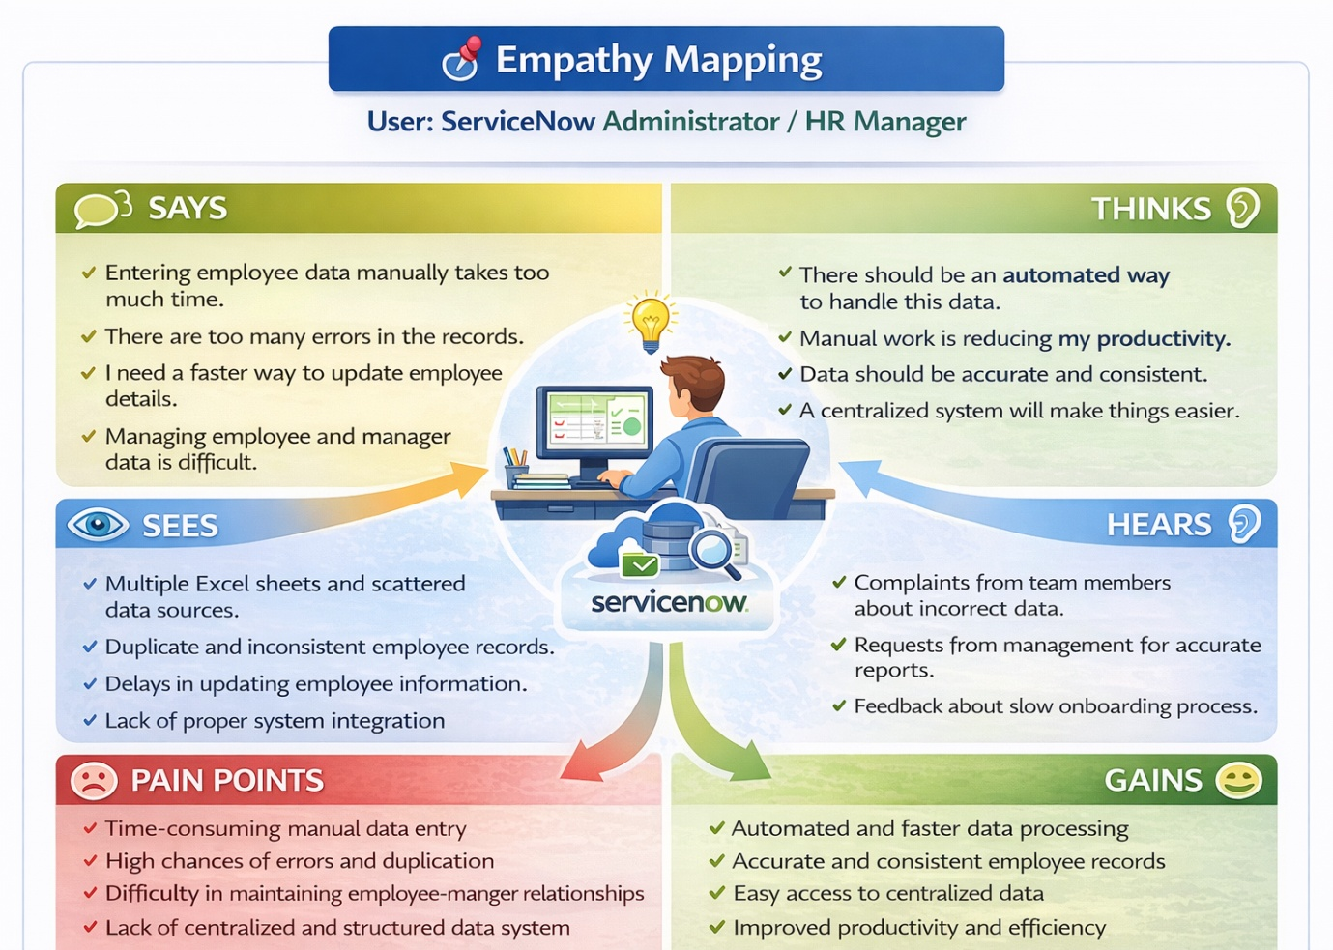

Example: Employee Information Management
